

***Heaven’s Light is Our Guide***

***Rajshahi University of Engineering & Technology***

**Department of Electrical & Electronic Engineering Lab Report**

**Course No:** EEE 3204

**Course Name:** Power Electronics Sessional

**Experiment No:** 03

**Experiment Name:** Experimental study of single phase controlled rectifier with resistive & inductive load

**Date of experiment:** 12/11/2022

**Date of Submission:** 03/12/2022

**Submitted By:**

Dibbayan Chowdhury Naba Roll: 1801174

Section: C

Session: 2018-2019

**Submitted To:** Md. Abdul Malek Assistant Professor,

Department of EEE,

Rajshahi University of Engineering & Technology.

**Experimental Setup:**

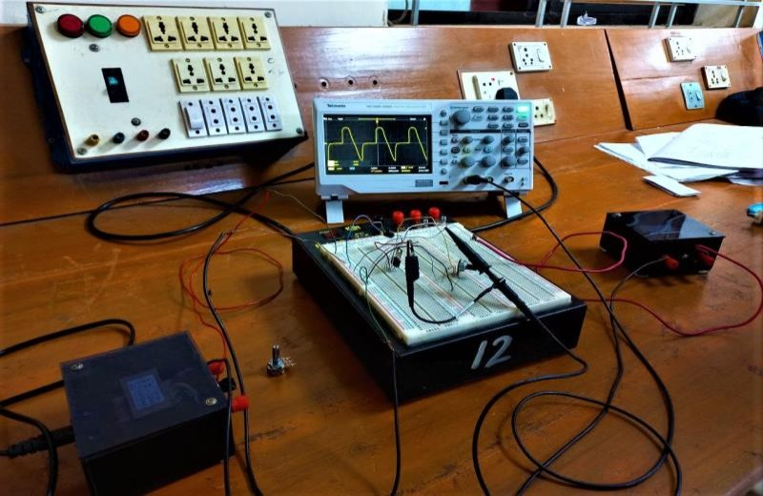

Fig.3.4: Apparatus Setup for the Experiment

**Output Waveshapes:**

**Resistive load**

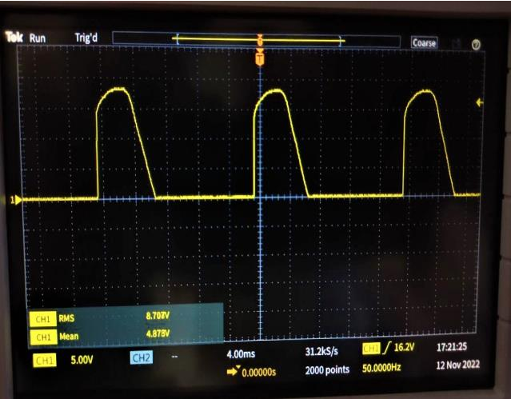

Fig.3.5: Output across resistor (low firing angle)

As soon as the thyristor T is fired at a firing angle, load voltage equal to the source voltage instantaneously appears across the load terminal. This is because, the thyristor is forward biased in between ωt = 0 to firing angle. Hence, once the thyristor is gated, it stars conducting. At ωt = π, the load voltage Vo reduces to zero.

As firing angle increases so does the waveshape becomes steeper.

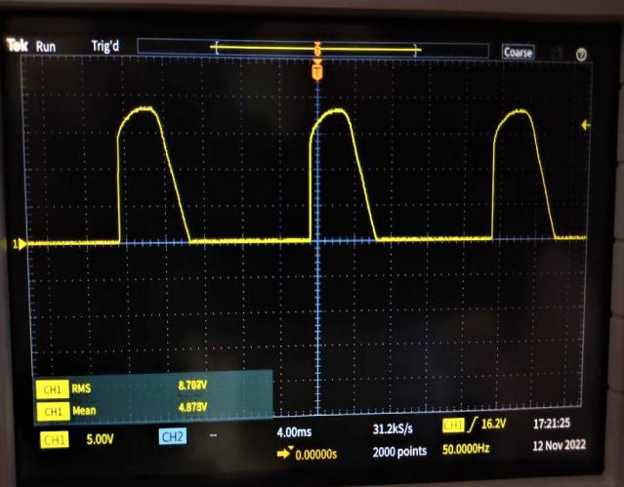

Fig.3.6: Output across resistor (high firing angle)

**Inductive load**

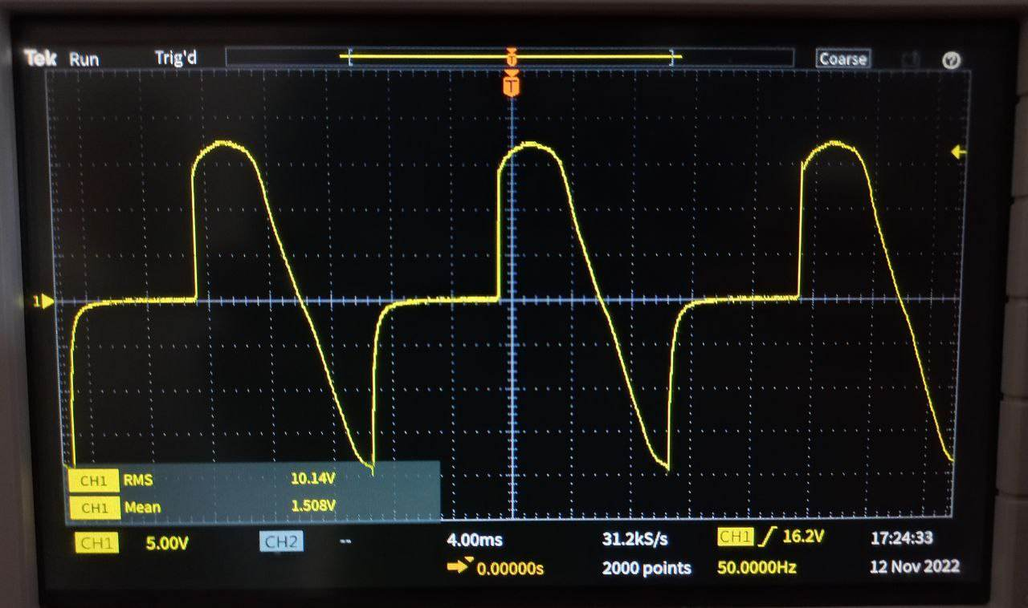

Fig.3.7: Output across inductor

When the thyristor is triggered, the load-current will increase in a finite-time through the inductive load. The supply voltage from this instant appears across the load. Due to inductive load, the increase in current is gradual. Energy is stored in inductor during certain time period. After that time period, the supply voltage reverses, but the thyristor is kept conducting. This is due to the fact that current through the inductance cannot be reduced to zero.

As firing angle increases so does the waveshape becomes steeper.

**Resistive- inductive load**

In positive half cycle, SCR starts conduction at firing angle. Here drop across SCR is small & neglected so output voltage is equal to supply voltage. Due to 'RL' load, current through SCR increases slowly. At 'π', supply voltage is at zero where load current is at its max value. In positive half cycle, inductor stores energy & that generates the voltage. In negative half cycle, the voltage developed across inductor, forward biases SCR & maintains its conduction.

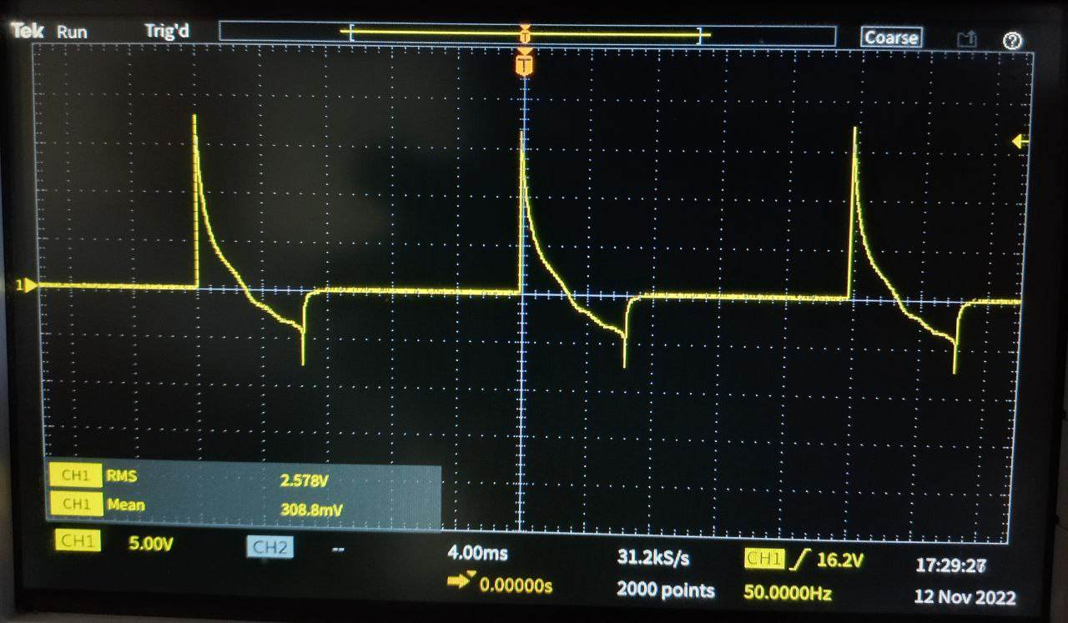

Fig.3.68 Output across resistor- inductor